Types of Homonyms
# Source: Chatgpt (GPT-4-turbo) at [8/1/2025]
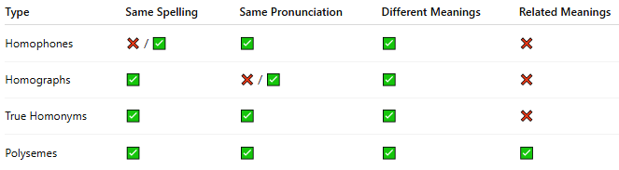

Type | Same Spelling | Same Pronunciation | Different Meanings | Related Meanings
Homophones | ❌ / ✅ | ✅ | ✅ | ❌
Homographs | ✅ | ❌ / ✅ | ✅ | ❌
True Homonyms | ✅ | ✅ | ✅ | ❌
Polysemes | ✅ | ✅ | ✅ | ✅

